003 BUS SYSTEM

Data from “Power System Stability and Control” (Prabha Kunder) pp.843
Diagram by Lei SHI 2000.3.17

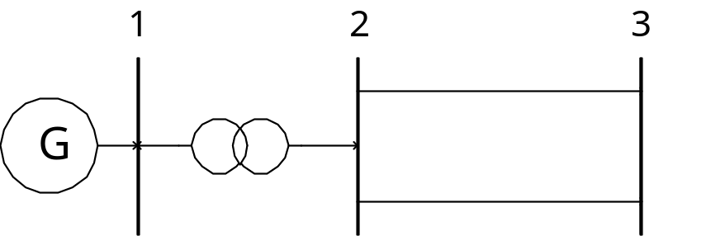

Infinite Bus

